DEVELOPER’S GUIDE
Introduction
- This Developer’s Guide provides technical information about the Origami Hub project. It is intended for developers who want to understand the system structure and functionality

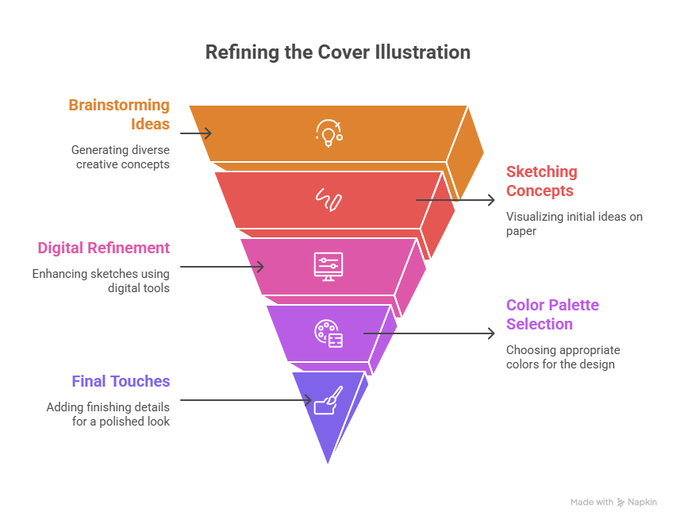
Team Members
- The development of the project Origami Hub was completed through effective teamwork and coordination among all team members. Each member actively participated in different phases of the development process, including planning, design, documentation, and testing.

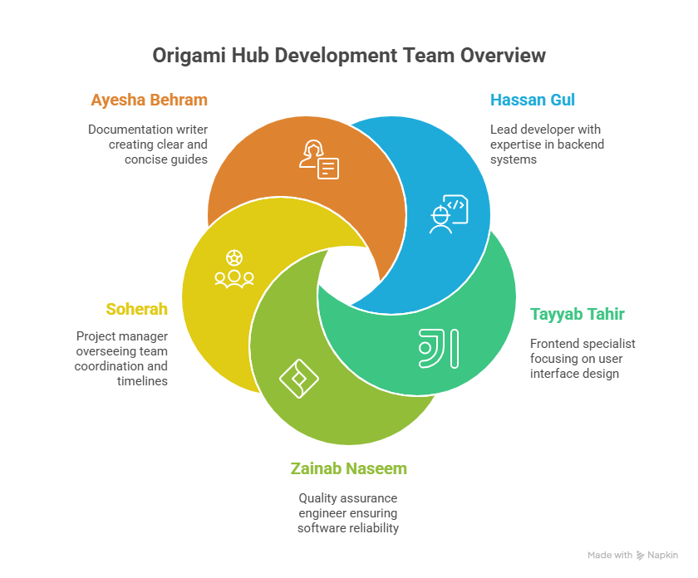

Project Overview
- Origami Hub is a web-based application designed to display origami designs in categorized and visual form with a simple user interface.

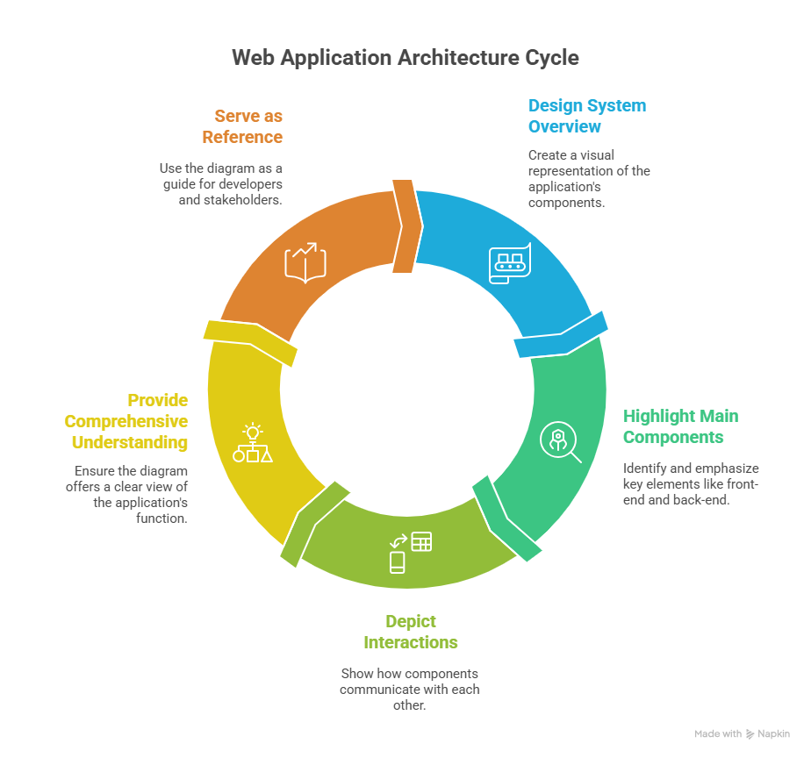
System Architecture
- The system follows a basic web architecture consisting of frontend interface and optional backend and database components.

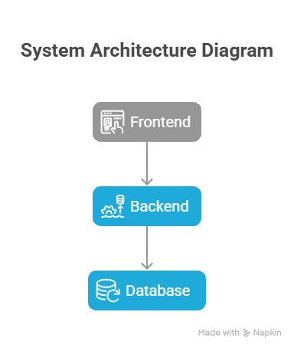
Module Description
- The system is divided into multiple modules such as Home, Categories, Gallery, and Navigation, each handling specific functionality.
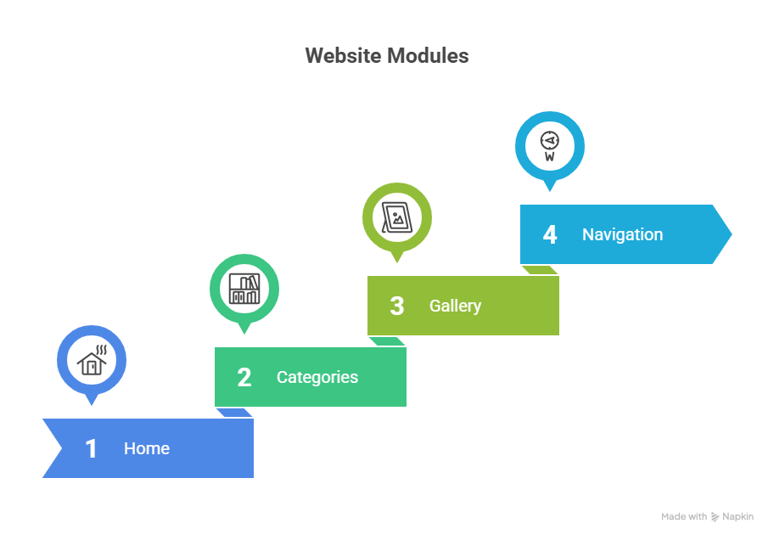
Database Design / Structure
- The database stores origami categories and image information in structured tables for easy data management.
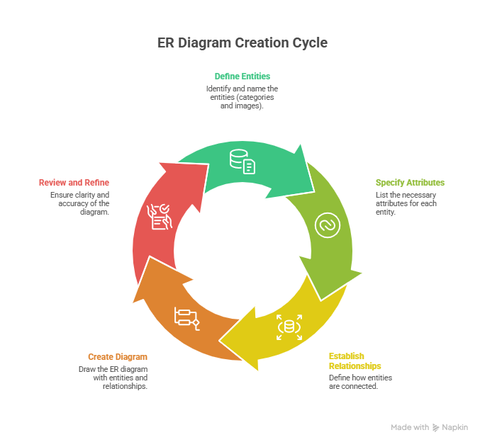
Flowcharts & DFD
- Flowcharts and Data Flow Diagrams explain the system process and user interaction with the application.

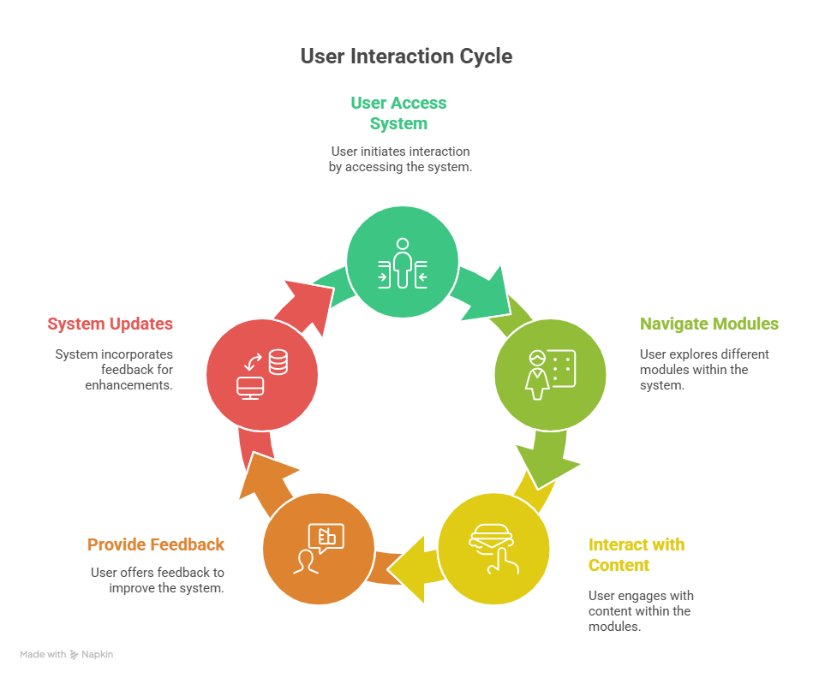
Code Structure
- The source code is organized into separate files and folders with proper comments for better understanding.

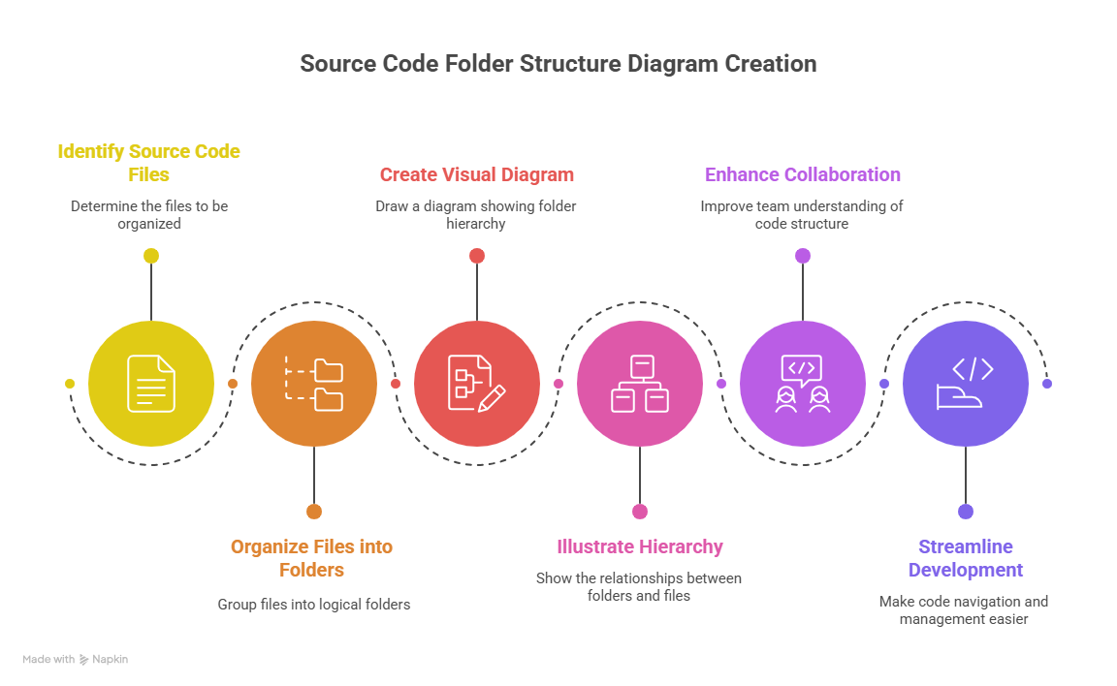
Future Enhancements
- Future improvements may include user login, admin panel, and tutorial features.

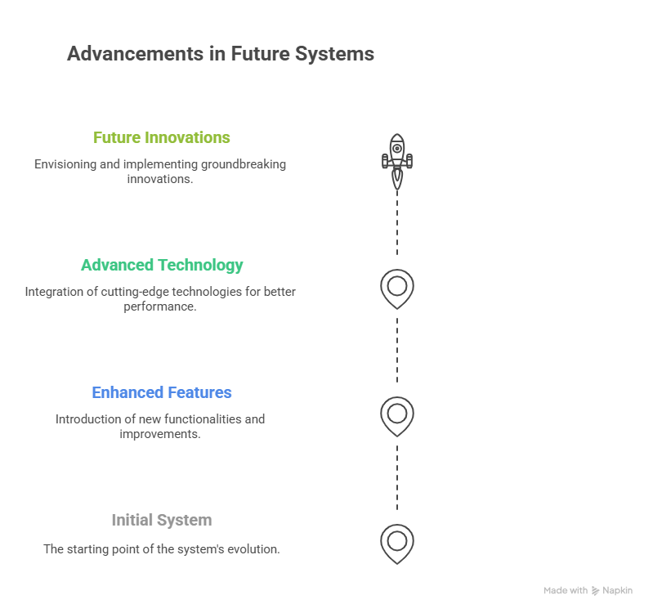
Conclusion
- This guide helps developers understand and maintain the Origami Hub project efficiently.

